HTML5 has many elements that enable developers to create well-structured and varied websites. These HTML5 elements provide ways to separate an HTML document into divisions, create headers and footers, define sections, create headings, and delineate the body of the document. In addition, there are many HTML5 elements that allow the user to interact with the website, inputting information in various formats like dates, times, numbers, email addresses, and much more besides. To be able to create the structure you want for your site, you must be familiar with some of these elements.

HTML5 Tags and Structural Elements

Hello. Welcome to HTML5 Tags and Structural Elements. After watching this video, you will be able to: List specific elements to HTML5 and Describe HTML5 structural elements: section, article, header, footer, figure, figcaption. There are many HTML5 specific elements. The table shows some of them. Notice that the HTML5 element tags have intuitive names, such as audio that is used to embed sound content, and canvas that is used for graphical content. Not all of these element tags are covered in this video, so take a moment to read through the table. This table shows more HTML5 elements. The last tag in the table is the comments tag. Comments in HTML can assist the developer to explain what the code does. The browsers do not display these comments, unless the viewer views the source. In a division-based layout, each part of a page that you want to format differently is separated into its own division. Think of the natural divisions into which you can divide the page that is shown here. These divisions might include the page title, a banner with selectable tabs, an area for the image, and further blocks for text and thumbnail images. The &lt;div&gt; tag was not introduced in HTML5, but is a good starting point for laying out a page or document. Then, you can use other HTML5-specific structural elements inside the &lt;div&gt; tag. Most HTML elements have a semantic meaning. In other words, the element describes either the function or the type of data that is contained within. For example, a &lt;p&gt; element is a paragraph that usually contains some text. In contrast, the &lt;div&gt; tag has no innate semantic meaning besides the logical grouping of the content. You can use these dedicated elements to mark up your website, rather than using the generic &lt;div&gt; or <s> elements.</s> An &lt;article&gt; defines a block of code that can be distinguished from the rest of the page. A <s> defines a logical separation in the document such as the numbered chapters</s> of an online manual. A &lt;header&gt; element is used to group the headers for a page. The &lt;footer&gt; defines the area at the bottom of the page. This code example shows some of the HTML5 structural element. Here, the &lt;article&gt; element is used to create an online news report. The &lt;article&gt; includes a header. Within the &lt;article&gt;, the page is marked up into sections that have their own headers. The page also includes a &lt;footer&gt; element. The &lt;aside&gt; tag is used to provide additional information that is related to the main discussion. The aside tag lets you extract and display further content or go to additional resources without detracting from the main discussion. The &lt;figure&gt; tag defines a self-contained element that is referred to from the main content. The &lt;figure&gt; element can be used to embed graphics, images, or code sections. The &lt;figurecaption&gt; tag defines the caption for the contents of the &lt;figure&gt; element. Websites typically have sections that are dedicated to navigational links that go to these sites or for moving between pages of a single application. In HTML5 syntax, these navigational links are placed inside a &lt;nav&gt; tag. The &lt;nav&gt; tag is a convenience tag for grouping navigational links in a web page. Websites typically have sections that are dedicated to navigational links that go to these sites or for moving between pages of a single application. In HTML5 syntax, these navigational links are placed inside a &lt;nav&gt; tag. The &lt;nav&gt; tag is a convenience tag for grouping navigational links in a web page. In this video, you learned: Tags provide control within an HTML5 document. Some tags provide structural elements: The &lt;div&gt; tag separates areas in a document into divisions, enabling you to apply different styles to different parts of a document. Dedicated elements like &lt;article&gt;, <s>, &lt;header&gt;, and &lt;footer&gt; are more specific than</s> the generic &lt;div&gt; element. The &lt;aside&gt;, &lt;figure&gt; and &lt;figcaption&gt; tags enable you to group content. And the &lt;nav&gt; tags enable you to group navigational links.

HTML5 Input Element: Attributes for the Input Tag

Hello. Welcome to HTML5 Input Element: Attributes for the Input Tag. After watching this video, you will be able to: Describe the attributes of the HTML5 input element input type attributes tel, email, date time, number, range, and color. The &lt; input type= "color" / &gt; attribute allows the user to select a color. The dialog varies depending on the browser. Some browsers don’t support this input type. In non-supporting browsers, this input type is displayed as a regular text input field into which the user might type a valid color name or color code. The &lt; input type="date" &gt; attribute is a date control (year, month, day) with no time zone. The example shows the input type="date" field as it is seen in Google Chrome. The input dialog varies from browser to browser. The datetime-local attribute provides input for a date and time (year, month, day, hour, minute, AM/PM) with no time zone. The datetime-local input field is displayed as a drop-down calendar in the Google Chrome browser. The time can be typed or entered using the spinner control. The &lt; input type="email" &gt; attribute is displayed as a regular text input field. It provides feedback when the input does not follow the email format. The &lt; input type="number" &gt; takes a numeric value as input. You can optionally specify the minimum, maximum values, step size, etc. The example shows the number selector in the Chrome browser. Only the numbers between 5 and the 10 are available for selection. The &lt; input type="range" &gt; takes a numeric range as input. The example shows the number selector in the Google Chrome browser. Only the numbers in the range of the minimum and the maximum are available for selection. The range attribute displays a slider with the range of values between the minimum and maximum. Only the slider itself is shown. Additional JavaScript code is needed in order to display the value of the slider. The differences between &lt; input type="search"\ &gt; and &lt; input type="text" / &gt; are mostly in style. WebKit-based browsers return a history of recently searched text strings. The search input field on the Safari browser has rounded corners. The input type="tel" pattern="[parameters]" attribute expects a telephone number as input. On its own, the &lt; input type="tel" &gt; provides nothing more than a text entry field in the browsers. It does not enforce numeric only input since many telephone numbers include other characters, such as the plus sign and hyphens. You need to supply your own pattern matcher if you want the browser to validate the telephone number. The URL attribute is used to validate that the user typed in a properly formatted URL or web address. The &lt; input list="some_list" &gt; uses the &lt;datalist&gt; feature. Not to be confused with the &lt; select &gt; element. The &lt;datalist&gt; options are only suggestions. Useful for auto-complete functionality. You can fill the list by nesting &lt;option&gt; elements inside the &lt;datalist&gt; tag. These options are the types of fruits listed in the drop-down list. Placeholder text is used to provide hints of what the input text format looks like. The placeholder fills the input text field with the example values in a lighter shade of text. The form does not submit the placeholder text value if the input text is not overwritten. The required attribute implies that some text must be typed. The requirement to type some input applies even if the field contains placeholder text. What happens if browser-based validation is not supported for these input attributes? There are several options to performing validation in browsers that do not support all HTML5 input attributes. You can use JavaScript and JQuery libraries. You can assume that more browsers will support these features over time, and leave all final validation to server-side processing. You can code client-side validation that is attached to the form submit event handler to validate all the fields on the form when the form is submitted. In this video, you learned: Common attributes of the &lt; input &gt; tag and how to implement validation fallback.

Additional HTML Elements: HTML fieldset and legend Tag


Special HTML Elements
In this section, we will explore a tag found within the <form> tag called <fieldset> tag and <legend> tag.
Duration: 15 min

Objectives
After completing this reading section you will be able to:
- Use <fieldset> Tag appropriately in HTML pages
- Use <legend> Tag to decorate your fieldset.

HTML fieldset tag
- The HTML <fieldset> tag is found within the <form> tag and is used to group related elements in an HTML form inside a box.
- There is no restriction to the kind of elements that can be inside a fieldset. But they are mostly used to group related input type of elements, as shown in the example below.
- The elements grouped in a fieldset can be . This element can be specially useful in large forms, where readability and ease of access can be improved with segmentation. Browsers will most likely render a frame around the grouped controls.

Syntax
<fieldset> Contents... </fieldset>

Attribute
- disabled: It specifies that the elements belonging to the fieldset should be disabled.
- form: It specifies id of the form the fieldset is to be considered a part of.
- name: It specifies the name for the fieldset.

Example
In the first example we will try to create a form:
<!DOCTYPE html>
<html>
<body>

<h1>The fieldset element</h1>

<form>
<fieldset form="user_regn" name="user_details">
<label for="fname">First name:</label>
<input type="text" id="fname" name="fname"><br><br>
<label for="lname">Last name:</label>
<input type="text" id="lname" name="lname"><br><br>
<label for="email">Email:</label>
<input type="email" id="email" name="email"><br><br>
<label for="birthday">Birthday:</label>
<input type="date" id="birthday" name="birthday"><br><br>
</fieldset>
<input type="submit" value="Submit">
</form>
</body>
</html>

Output
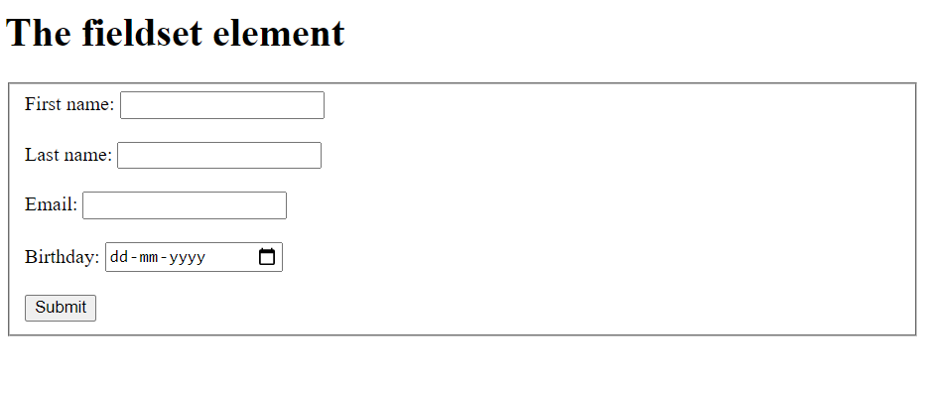
Note: You can edit the form as per your convenient

HTML legend tag
A fieldset can additionally have a title or name, that can be provided by legend. The <legend> tag is used with the <fieldset> element as a first child to define the caption for the grouped related fields This tag is also commonly referred to as the <fieldset> element. By using <legend> tag with <fieldset> elements, it is easy to understand the purpose of grouped form elements.

Example
To understand the <legend> tag, let's add this tag to the above example and see what will be the output:
<!DOCTYPE html>
<html>
<body>

<h1>The fieldset element</h1>

<form>
<fieldset form="user_regn" name="user_details"> <legend>Personal Details:</legend>
<label for="fname">First name:</label>
<input type="text" id="fname" name="fname"><br><br>
<label for="lname">Last name:</label>
<input type="text" id="lname" name="lname"><br><br>
<label for="email">Email:</label>
<input type="email" id="email" name="email"><br><br>
<label for="birthday">Birthday:</label>
<input type="date" id="birthday" name="birthday"><br><br>
</fieldset>
<input type="submit" value="Submit">
</form>
</body>
</html>

Output
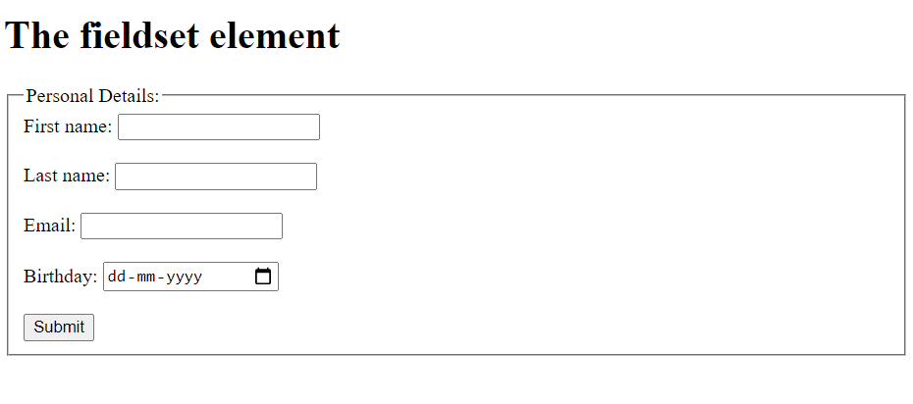

Congratulations! You have completed the exercise.

Module Summary
In this module, you learned that:
To structure a document, HTML5 uses elements like:
- <div>
- <header>
- <footer>
- <section>
- <body>
- <heading>
HTML5 uses the <input> tag to allow users to input information. It has many different types, including:
- Color
- Date
- Datetime-local
- Email
- Number
- Range
- Search
- URL

